ITI – Intro to programming (Java OOP) Lab 3
Mohammad Tarek Omar – Data Management

OOP Problems:
- Assignment 1: Implement these classes and Main class
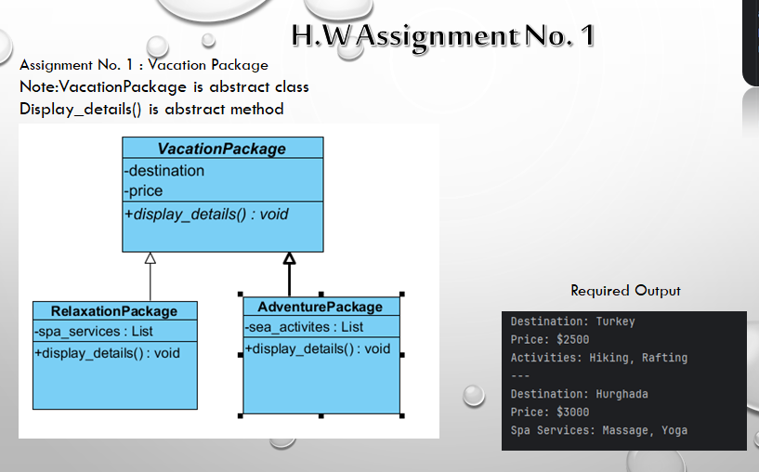
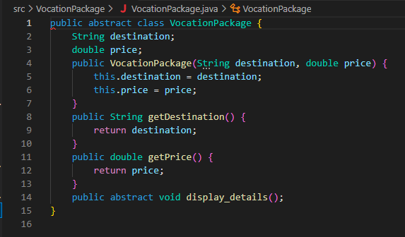
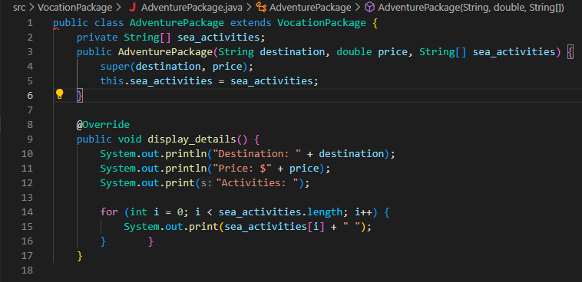
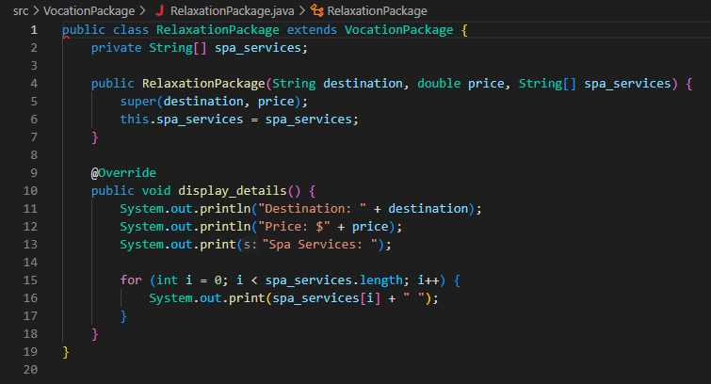
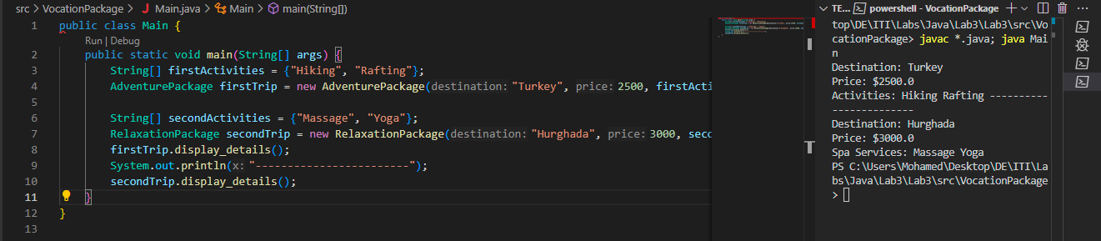

- Assignment 2: Implement these classes and Main class
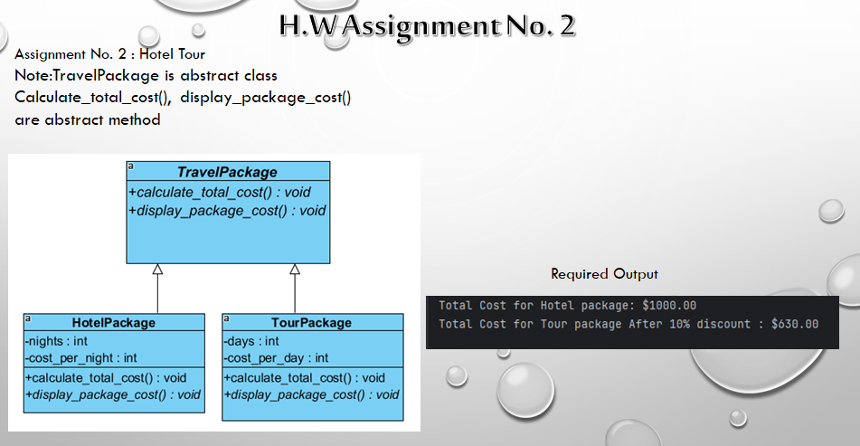
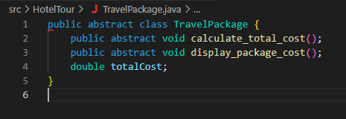
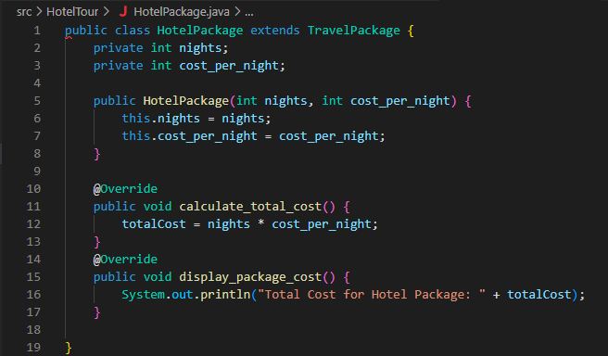
(to make method calculate_total_cost void, I had to add variable ‘baseCost’ to handle this..)
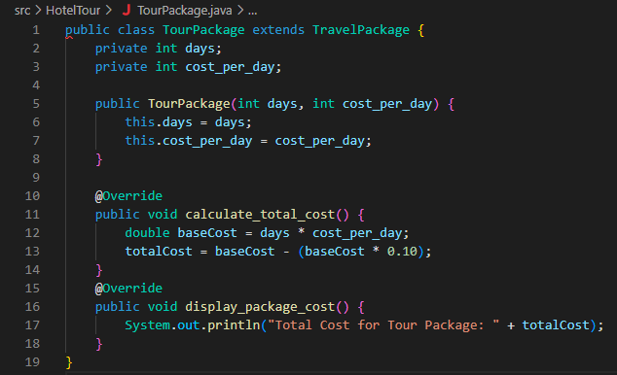
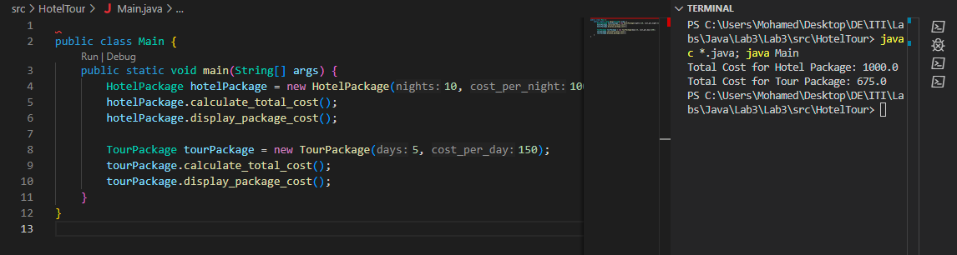
- Assignment 3: Implement these classes and Main class
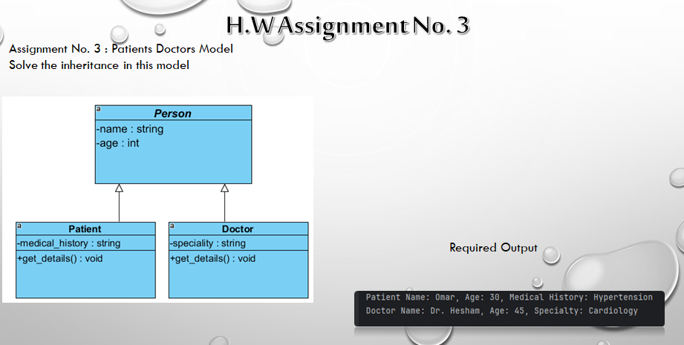
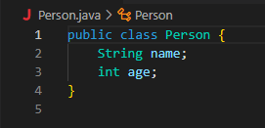
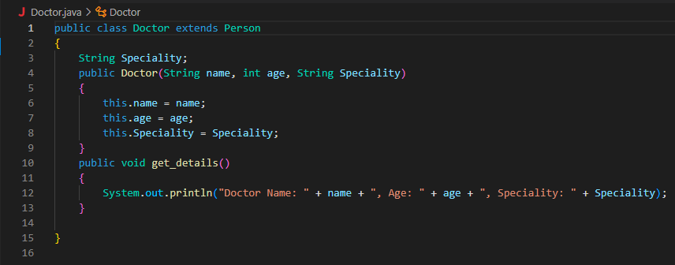
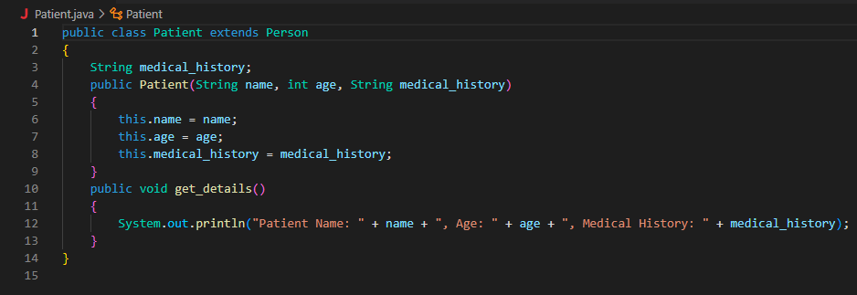
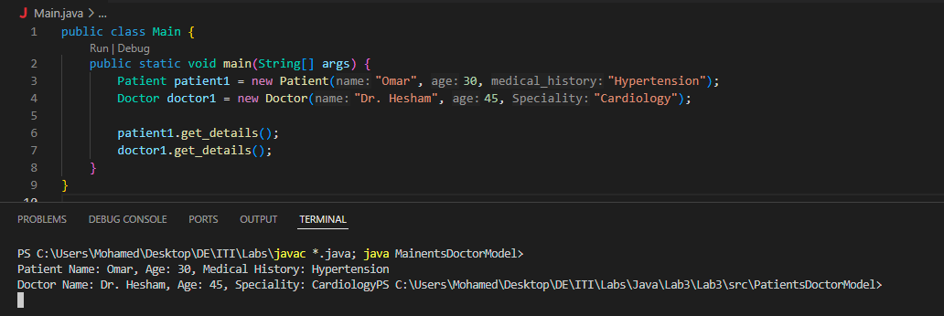
- Assignment 4: Implement these classes and Main class
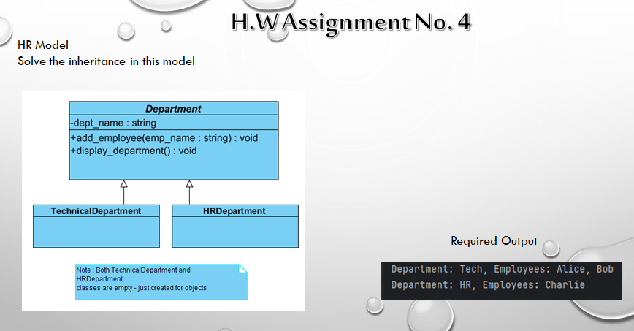
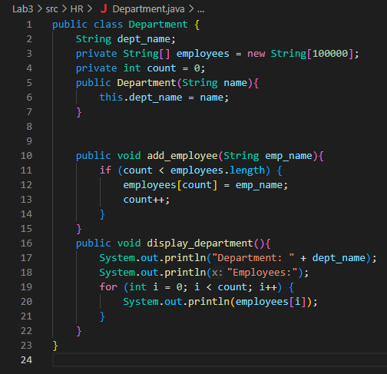
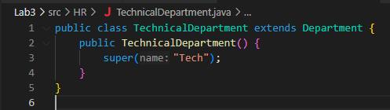
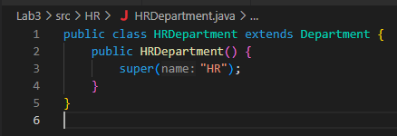
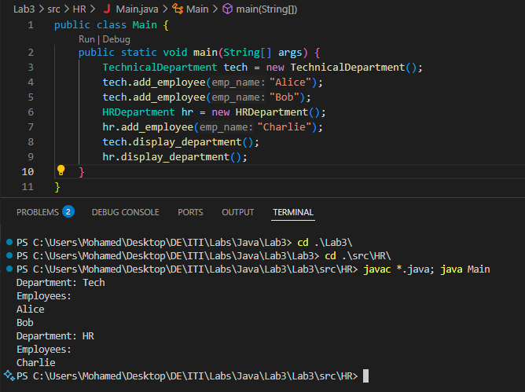

Bonus:
- What I did? When I run the program I found that there is no item details, so I looked at the Order class and I found that there were 2 uncompleted functions that need to be completed, addProductTocart and removeProductFromCart, I iterate on the itemlist and increment quantity by 1 and add with function add it as a new order item, and in removing I iterate also, decrement quantity by 1, and remove it with function remove. (I asked for a help in syntax from LLM in the second function removeProductFromCart)
